Mini Residency in Pediatric Dentistry
University of Minnesota School of Dentistry

Preliminary Program

FRIDAY

Lynda J. Young Conference Room (6-410 Moos HS Tower)

7:30 Breakfast

8:00 Course Introduction
Needs Assessment

8:30 LECTURE: Pediatric Guidelines of Patient Care
- AAPD guidelines and best practices
- Medical history
    - significant findings
    - implications for treatment
- Informed consent
- Parents’ presence in the operatory

10:00 Refreshment break

10:15 LECTURE: Pain and Anxiety Management for Children
- behavior management
- active and passive stabilization methods
- when to discuss referral
- local anesthesia
- nitrous

11:30 LECTURE: Review Key Points for Individualized Prevention Plans
- standard of care of prevention at different ages

12:00 Lunch (included)

12:30 LECTURE: Selecting the Most Appropriate Restorative Procedures
- non-surgical approaches: SDF and glass ionomer cements
- simple restorations
- advanced restorations

2:00 Refreshment break

2:15 LECTURE: Selecting the Most Appropriate Restorative Procedures
- stainless steel crowns
- management of hypoplastic permanent molars (MIH)

3:45 Refreshment break

4:00 LECTURE: Management of Developing Occlusion in the Primary and Mixed Dentition
- dental development
- anomalies of eruption
- anterior and posterior crossbites
- appliances

5:00 Adjourn

SATURDAY

Lynda J. Young Conference Room (6-410 Moos HS Tower)

7:30 Reconvene. Continental breakfast.

8:00 Question and answer session

8:15 LECTURE: The Whys and the Hows of Pulp Therapy
- diagnosing the pulp status through clinical and radiographic images
- deep carious lesions
- determining the appropriate pulp therapy
- indirect pulp treatment (IPT), stepwise excavation
- pulpotomy, pulpectomy

10:00 Refreshment break

4th Floor Preclinical Laboratory

10:15 BENCH-TOP EXERCISE: Pulpotomy/Pulpectomy
- prepare tooth for pulpotomy

BENCH-TOP EXERCISE: Stainless Steel Crown (SSC) Preparation/Adaptation and RMGI Preparation/Restore
- prepare tooth for stainless steel crown
- adaptation of stainless steel crown
- prepare and restore class I and II primary molar lesions with RMGI

Lynda J. Young Conference Room (6-410 Moos HS Tower)

12:30 Lunch (included)

4th Floor Preclinical Laboratory

1:15 BENCH-TOP EXERCISE: Continue RMGI and/or SSC Exercise

1:45 BENCH-TOP EXERCISE: Arch Length Maintainer Design/Fabrication
- adapt band, impression, pour-up impression
- discussion on case selection
- one appointment non-solder single tooth space maintainer – B&L (DeNovo®)
- one appointment non-solder single tooth space maintainer - SSC (DeNovo®)

3:00 Refreshment Break

Lynda J. Young Conference Room (6-410 Moos HS Tower)

3:15 LECTURE: Most Common Traumatic Injuries in the Primary and Mixed Dentition
- crown and root fractures
- luxations, avulsion

5:00 Adjourn

SUNDAY

Lynda J. Young Conference Room (6-410 Moos HS Tower)

7:30 Reconvene. Continental breakfast.

8:00 LECTURE: Anterior Strip Crowns and Posterior Pediatric Zirconia Crowns
- case selection
- techniques

9:15 Refreshment break

4th Floor Preclinical Laboratory

9:30 BENCH-TOP EXERCISE: Anterior and Posterior Esthetic Restorations
- prepare anterior teeth for celluloid crowns
- adaptation of celluloid crown forms
- prepare anterior and posterior Zirconia crown (optional!)

11:00 CASE PRESENTATIONS: Putting it All Together

12:00 Question and answer session. Course wrap up.

12:15 Adjourn

Meet Our Course Director

Daniela Rodrigues Silva, DDS, MS, is the Dr. Thomas K. Barber Endowed Chair, the Director of the Pediatric Residency Program, and Clinical Professor of the Section of Pediatric Dentistry in the Division of Preventive and restorative Sciences at the UCLA School of Dentistry. She completed her dental degree at the Federal University of Goiás, Brazil, a pediatric dentistry certificate at the University of Castelo Branco, Brazil, and her certificate and master’s degree in pediatric dentistry at the University of Michigan. Before her work in California, Dr. Silva served as the Residency Program Director at the University of Florida College of Dentistry. A Diplomate of the American Board of Pediatric Dentistry, Dr. Silva is also an active member of the American Academy of Pediatric Dentistry and the California Society of Pediatric Dentistry. Her research areas of interest include caries diagnosis and prevention, pulp therapy, restorative dentistry, and dental trauma.

Disclosure Summary

It is the policy of the University of Minnesota Office of Continuing Dental Education to ensure balance, independence, objectivity and scientific rigor in all of its sponsored educational activities. All participating speakers, course directors, and planning committee members are required to disclose to the program audience any financial relationships related to the subject matter of this program. Relationships of spouse/partner with proprietary entities producing health care goods or services should be disclosed if they are of a nature that may influence the objectivity of the individual in a position to control the content of the CDE activity. Disclosure information is reviewed in advance in order to manage and resolve any possible conflicts of interest. Specific disclosure information for each speaker, course director, and planning committee member will be shared with the audience prior to the speaker’s presentation.

Continuing Dental Education Staff members have nothing to disclose.

The following information was received from our speakers for this course. It is not assumed these financial interests or affiliations will have an adverse impact on course presentations. They simply are noted here to fully inform course participants.

Daniela Rodrigues P. Silva, DDS, MS
drsilva@g.ucla.edu
Indicated no relevant affiliations or financial interests. Speaker does not intend to discuss an off-label/investigative use of a commercial product/device.

The University of Minnesota School of Dentistry has an obligation to disseminate new knowledge related to dental practice. Some programs offered through Continuing Dental Education may introduce materials, techniques or product references that are subject to debate. Sponsorship of courses by the University of Minnesota School of Dentistry does not necessarily imply endorsement of specific philosophies, procedures or products by this institution. Recognizing that you may be learning about new procedures, techniques and materials that you may not yet be familiar with, we ask that you take every precaution when implementing these new materials and techniques into your practice.

The University of Minnesota School of Dentistry is an ADA CERP Recognized Provider.

ADA CERP is a service of the American Dental Association to assist dental professionals in identifying quality providers of continuing dental education. ADA CERP does not approve or endorse individual courses or instructors, nor does it imply acceptance of credit hours by boards of dentistry.

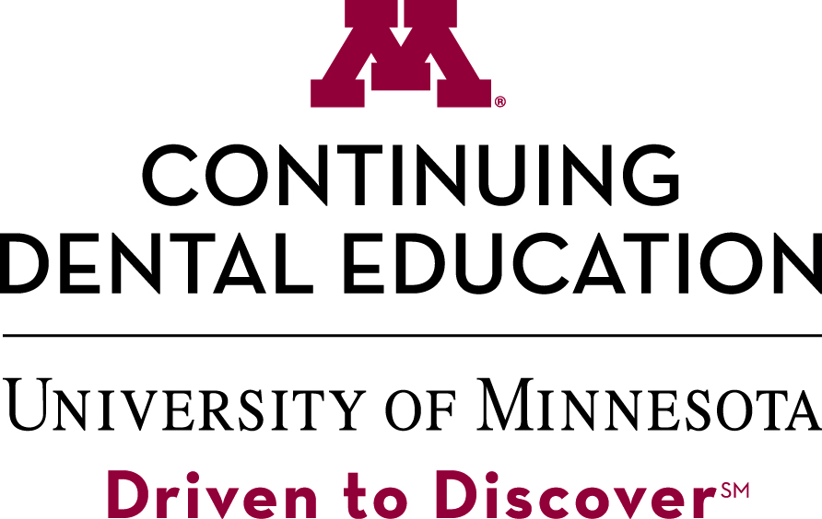
Concerns or complaints about a CE provider may be directed to the provider or to the Commission for Continuing Education Provider Recognition at ADA.org/CERP.

